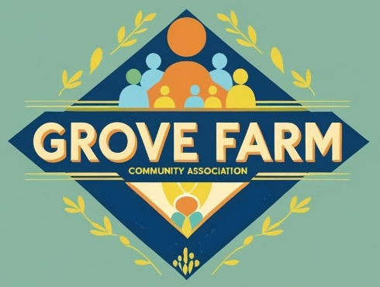
Grove Farm Community Centre
Booking Proforma
Grove Farm Community Centre is owned, run and managed by Grove Farm Community Association (Charity Reg No 508818)
Fill in the form as clearly as you can. If you are going to print it off and send it please fill in with black ink. Please read the Terms and Conditions carefully before committing,
Purpose of Hire
Name of Hirer
Organisation (if applicable)
Address
Post Code:-
Telephone number
Email Address

Date(s) of hire | Start Time | End Time | Notes

Room hire charges and payment options are all in the Terms and Conditions, please complete as applicable to your booking:-
Booking type  (delete as appropriate) | No of hours |  |  |  | Total booking cost
Booking type  (delete as appropriate) | No of hours | Meetings room only | Kitchen  (if required) |  | Total booking cost
Community rate: -  Local groups who have no access to funding and pay their own expenses. |  | £10.00  Per hr | £5.00 per booking
Standard rate: -  All bookings not covered by the Community rate |  | £12.00  Per hr | £5.00 per booking

- Please make cheques payable to Grove Farm Community Association.
- For BAC’s payments Sort code 30-84-79. account number 39925468
Please sign below
I have read the Hire Agreement and the Booking Proforma and agree to abide by them both.

Signed …………………………… Print name…………………………..Date……………………
Contacts:- Roy – 01263860756 or Andy – 07868 660756 / email grovefarmcc@gmail.com

